English Idioms
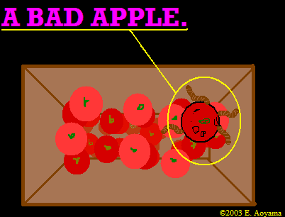
Idioms are phrases and sentences that do not mean exactly what they say. Even if you know the meaning of every word in the see or hear, you may not understand the idiom because you don't understand the culture behind it. Proverbs are wise sayings that help teach lessons.

1. A bad apple

Meaning:
A (morally) bad person who makes a whole group bad.
A bad apple is someone who has a bad effect on a whole group or system.
People also say, "One bad/rotten apple spoils the (whole) bushel/barrel."
Example:
The corruption in the government started with a bad apple, a high official two years ago. Now the whole system is corrupt.

2. (Have / Get) Butterflies in someone's stomach

Meaning:
Very nervous or excited before doing something important such as giving a speech and taking a test.
If you have butterflies in your stomach, you are very nervous and/or excited about something you are going to do soon.

Example:
He always gets butterflies in his stomach before taking a test.
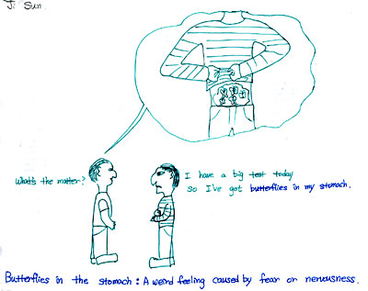

3. Cast pearls before swine

Meaning:
Offer or show something valuable, good, or beautiful to someone who does not understand its value
If you are casting pearls before swine, you are wasting your time showing or offering something very helpful or valuable to someone who does not understand or appreciate it.

Example:
Don't bother explaining Shakespeare to Bob. It would be like casting pearls before swine.
Tom wouldn't listen to Sarah's wise advice. She was just casting pearls before swine.
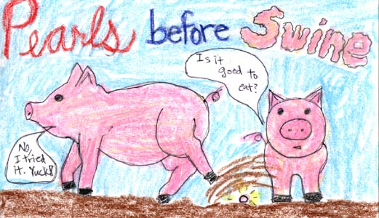

4. Be (as) cool as a cucumber

Meaning:
very calm and relaxed even in a difficult situation
If someone is (as) cool as a cucumber, he/she is very relaxed and/or calm when you expect him/her to be nervous or upset.

Example:
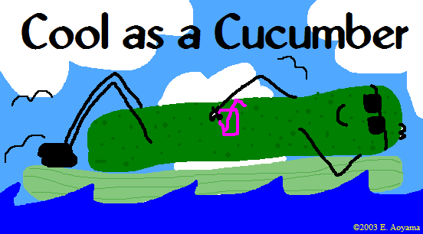
He had very bad news last night, but he came to the office as cool as a cucumber this morning as if nothing had happened.
She was cool as a cucumber even right after she was fired.

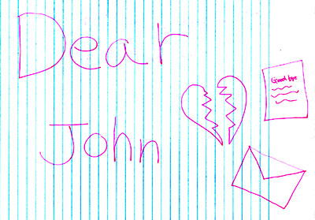
5. Dear John letter

Meaning:
A letter from a woman to her boyfriend or husband telling him that she doesn't love him anymore.
If a woman writes a Dear John letter to her boyfriend (or husband), she tells him that she wants end their relationship.
Example:
His girlfriend wrote him a Dear John letter and moved to Japan.

6. Eat one's words

Meaning:
Admit that what you said was wrong.
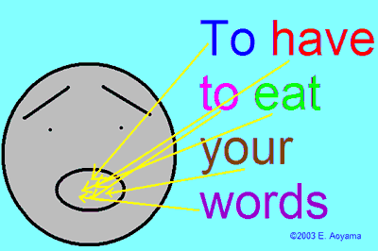
If you eat your words, you admit that the statements or predictions you made were wrong.

Example:
Tom said Nancy would never succeed in her business, but after seeing her business grow, he had to eat his words.
I taught a grammar rule in my ESL class, and one of my students said I was wrong. After I checked it in dictionaries and asked other teachers, I found she was right. I had to eat my words in the next class.

7. A frog in someone's throat / A frog in the throat
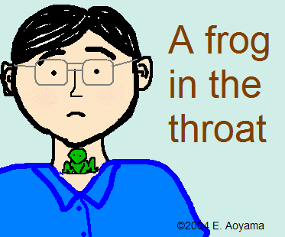
Meaning:
If you have a frog in your throat, you have a sore throat, or your throat is dry, and have difficulty speaking
because you want to cough.
Example:
In a speech contest last year, she suddenly got a frog in her throat and had a hard time speaking.
A: Why don't you sing with us in our next concert this Friday?
B: I wish I could, but I caught a cold and have a frog in the throat.

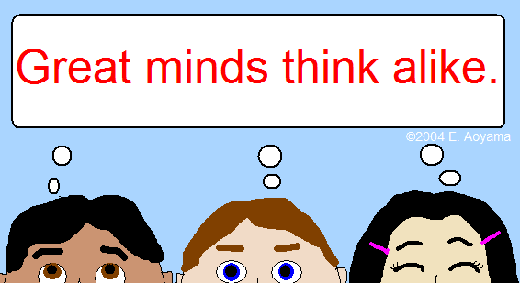
8. Great minds think alike.

Meaning:
This is a humorous expression that is used when you found out someone else was thinking about the same thing as you were.
If you say, "Great minds think alike," you say, jokingly, that you and someone else must be very intelligent or great because both of you thought of the same thing or agree on something.
Example:
A: I'm going to the concert tonight.
B: Oh, really? Me too. I heard the performers are excellent.
A: Great minds think alike.
(A and B meet in a restaurant unexpectedly.)
A: How did you know I am here?
B: This restaurant is a very nice place to spend an evening. Great minds think alike.

9. Hold One's Horses

Meaning:
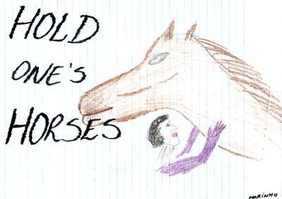
Wait; Be patient and careful; Wait and listen to what someone's saying.
You say "Hold your horses" to someone when he/she is impatient
or wants to do something immediately without thinking about his/her action and consequences carefully.
You tell him/her to be patient and wait.

Example:
Hold your horses. We are not ready to go yet.
Hold your horses. You might find a better one for the same price in another store.

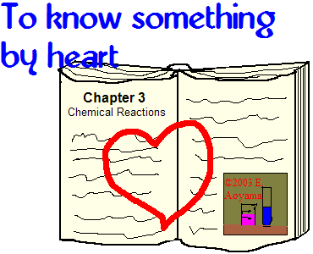
10. Know something by heart

Meaning:
To know something perfectly.
If you know something by heart, you know it very well and remember everything about it.
Example:
Sam is really a walking dictionary. He looks as if he knows the whole dictionary by heart.
Melissa loves Shakespeare. She has seen all of his plays so many times that she knows all the lines by heart.

11. Be like the cat that got the cream

Meaning:

(about a person) To be pleased with his/her ability or what he/she has done.
If you are like the cat that got the cream, you are very happy because you are happy about or satisfied with your own talent, accomplishment, or what has happened to you.
People also say, "You look like the cat that ate the canary."
Example:
At our high school reunion last week, Sue grinned like the cat that got the cream and told us about her success story.
She got 100% on her final exam yesterday. She looked like the cat that got the cream.

12. Be on the tip of someone's tongue

Meaning:
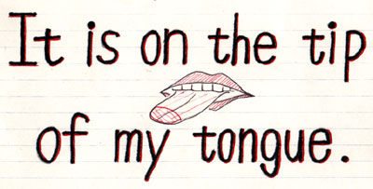
Cannot remember something such as a word or the name of a person although you think you know it and you will remember it soon.
If you say something is on the tip of your tongue, you mean you can almost remember it but not right away.
Example:
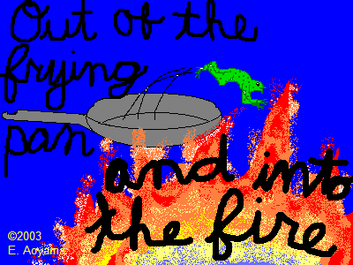
What's the girl's name there?
Wait a second, it's on the tip of my tongue. ... Yes! Her name is Joanne.
The teacher asked them a question. The answer was on the tip of his tongue, but another student raised her hand and said it first.

13. Out of the frying pan and into the fire

Meaning:

This idiom is used to say that someone gets out of a difficult or bad situation, but eventually goes into a more difficult or worse one.
If you say "Out of the frying pan and into the fire", you mean someone has moved from a bad or difficult situation to a worse one.
Example:
If the government accepts his new proposal, the nation will be jumping out of the frying pan into the fire. ( = It will make the situation worse.)
A: I've finally finished my assignment. It was very difficult, but the next one looks much harder.
B: Out of the frying pan and into the fire.

14. Pop the question

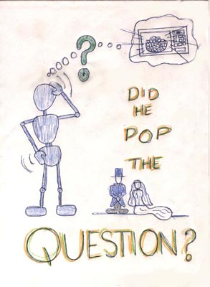
Meaning:
To ask someone to marry you
Culturally, it is usually the man who pops the question to a woman.
Example:
Steve has been dating Stephanie for two years. He decides that he wants to marry her. He is very nervous though, so he goes to ask advice from his best friend Eric.
"I think I'm going ask Stephanie to marry me. What do you think I should do?" asks Steve.
"You've decided to pop the question? That's wonderful! I think you should buy her roses and take her out for a nice dinner," replies Eric.

15. Put yourself in someone's shoes

Meaning:
Try to understand someone's situation.
If you put yourself in someone's shoes, you try to understand what his/her situation is like and think about it as if you were in the same situation.

Example:
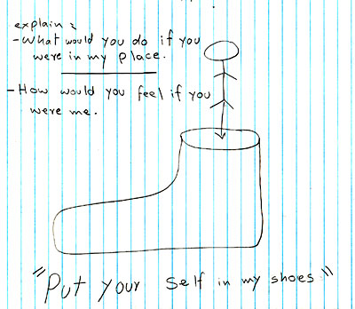
You need to take some time to put yourself in their shoes and understand them.

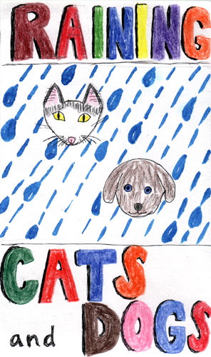
16. Rain cats and dogs

Meaning:
To rain very heavily.
If you say "It's raining cats and dogs," you mean it is raining very heavily.
Example:
They didn't cancel the game even though it was raining cats and dogs.
It will rain cats and dogs tomorrow, but he will go to work as usual.

17. Take to something like a duck to water

Meaning:
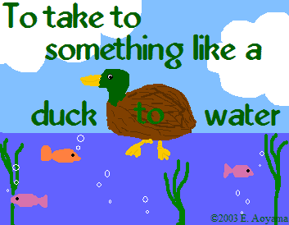
To learn how to do something very easily, quickly, and well when doing it for the first time, especially because of the person's natural ability.
If someone takes to something like a duck to water, he/she finds it very easy to do when he/she learns it for the first time. He/She finds that he/she is good at it naturally.
Example:
Sam is really a natural programmer. He took to programming like a duck to water even before he graduated from elementary school.
A: How's Sandy doing in her new job?
B: Very well. She's taken to it like a duck to water.

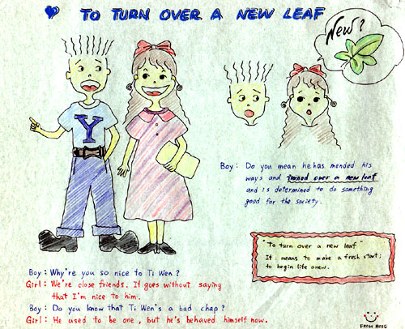
18. Turn over a new leaf

Meaning:
Start to do something again in a better way, forgetting past errors.
If you turn over a new leaf, you will start to behave better or become a better person.

Example:
Stephen said he has turned over a new leaf, and that he's going to quit smoking and drinking and start to exercise every day.
She decided to turn over a new leaf after her mother's death.

19. Wear one's heart on one's sleeve

Meaning:
Show emotions or feelings openly.
If you wear your heart on your sleeve, you openly express your feelings or emotions to others.
Example:
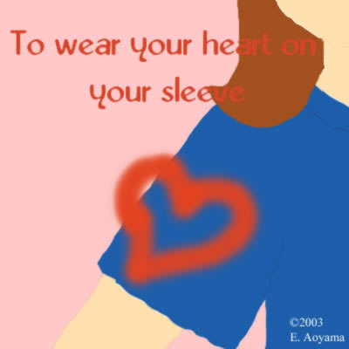
A: How did the interview go? Did he tell you what problems he has?
B: No, it was very difficult to make him open his heart and tell me his true feelings.
He's not a kind of guy who wears his heart on his sleeve.
Be careful when you talk to her. Never wear your heart on your sleeve.

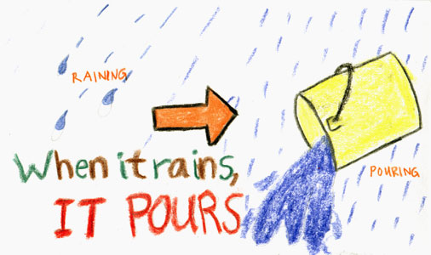

20. When it rains, it pours.

Meaning:
When one thing goes wrong, many other things also go wrong.
You say, "When it rains, it pours" when several similar, especially bad or annoying things happen at the same time.
Example:
I can't believe what happened to me last week! My dog ate my homework, and my computer crashed. Even worse, I got sick that night! When it rains, it pours!
A: No one in my family had been sick for many years, but everyone caught the flu last month at the same time.
B: When it rains, it pours.

